

**SOURCE CODE**

**Name: Chandana K R**

**Branch: B.Tech**

**Section: CSE**

**Course: Source Code**

**SEN: A86605223030**

**Submitted To: Dr. Monit Kapoor**

**Date of Submission: 06 June 2025**



Amity School of   
Engineering & Technology

**INDEX**

|  |  |  |
| --- | --- | --- |
| **SI** | **Topic** | **Date** |
| **1** | **Git & GitHub Fundamentals-** Install Git & GitHub- Basic Linux Commands | **31-01-2025** |
| **2** | **Committing & Viewing History-** Understanding Commits- Viewing Git Logs | **14-02-2025** |
| **3** | **Branching & Version Comparison-** Creating & Managing Branches- Using git diff | **07-03-2025** |
| **4** | **Remote Repositories-** Pushing Local Repos to GitHub | **16-05-2025** |
| **5** | **Collaboration & Conflict Resolution-** Inducing & Resolving Conflicts- Opening & Closing Pull Requests | **21-05-2025** |

1. **Git & GitHub Fundamentals**

* **Basic Linux Commands**
* ls – List directory contents
* ls -ah – List all files including hidden ones
* pwd – Print working directory
* cd .. – Move to the parent directory
* mkdir – Create a new directory
* cd <folder> – Change into a directory

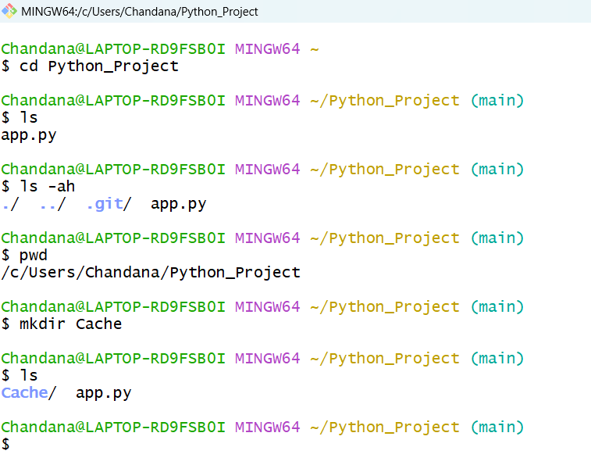

* **File Operations**
* vi <filename> – Open file in vi editor
  + Press i to insert
  + Press Esc to exit insert mode
  + Use :wq to save and quit
* cat <filename> – Display contents of a file
* ls -l – Show file permissions and details
* history – Show command history
* clear – Clear the terminal screen

ca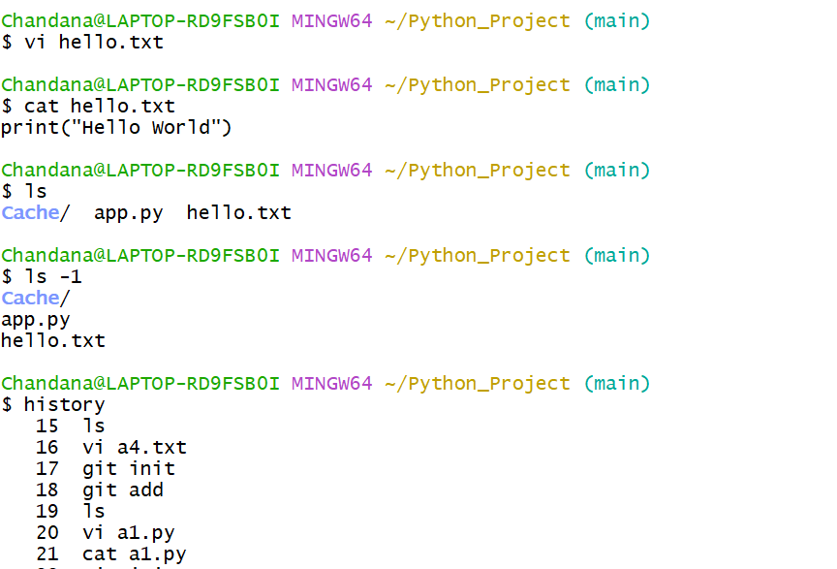

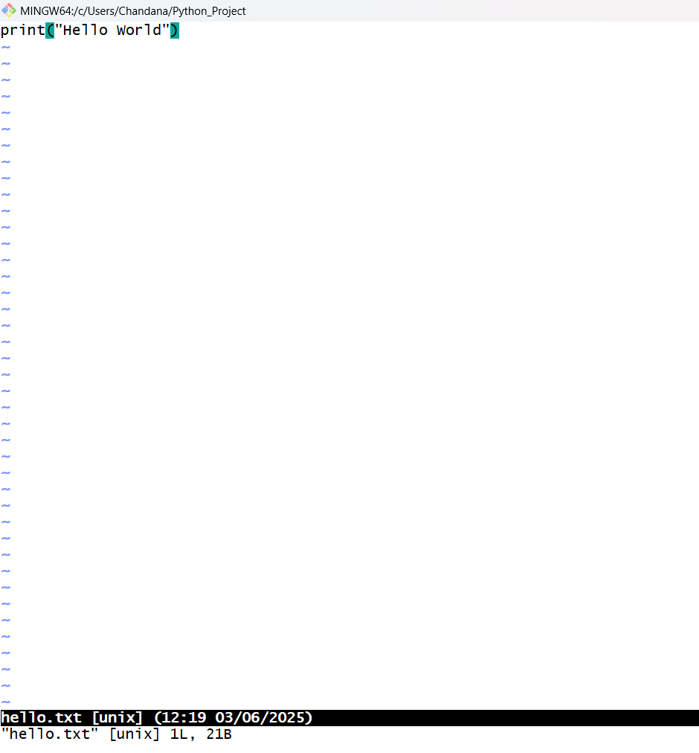

* **Git Initialization**
* git init – Initialize a Git repository
* git status – Show the working tree status
* git add <filename> – Stage a file for commit
* git commit -m "message" – Commit changes with a message
* Configure Git with your email and username

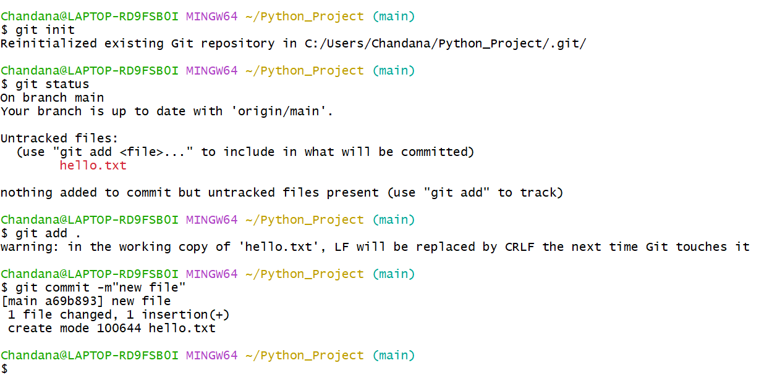

1. **Committing & Viewing History**

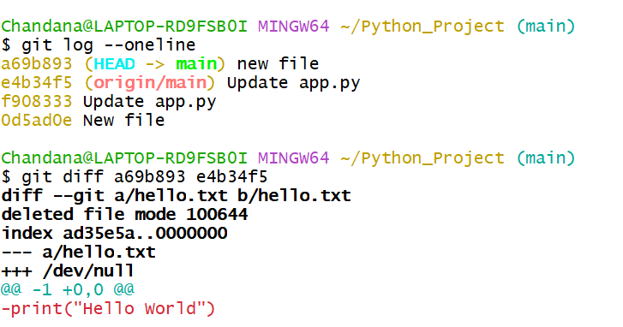

1. **Branching & Version Comparison**
2. **1. Branching:**

* git branch [branchname]: Create a new branch

* git checkout [branchname]: Switch to a different branch

* git checkout master: Switch back to the master branch

* **Concept:** Any branch and the master branch can have completely different codebases after many commits in their respective branches.

* **HEAD:** A special pointer that points to the last commit in the current branch.

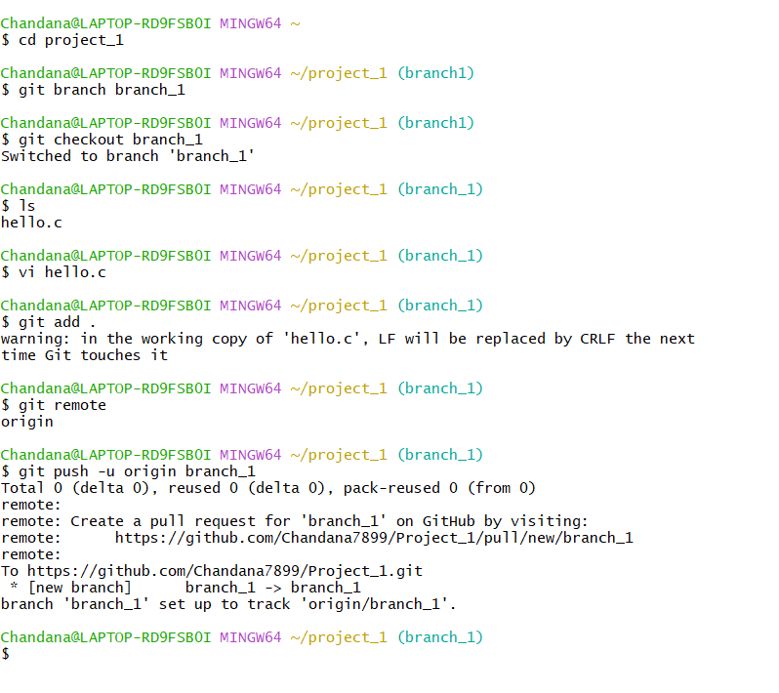

**2. Comparing Changes:**

* git diff: Show changes between commits, commit and working tree, etc. 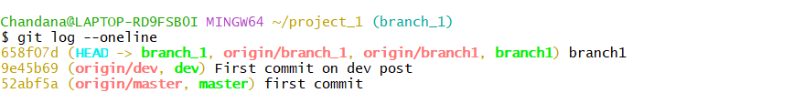

1. **Push Local Repository to GitHub (Remote)**

**Linking Local to Remote Repository:**

* git remote: Helps connect your local repository to a remote repository

* git remote add origin "[address of repo GitHub]": Add a new remote repository (e.g., github.com/kavya4kavya/Repo_1). origin is a common variable name but can be anything.

* git push -u origin master: Push local master branch to the origin remote. The -u flag sets the upstream. This is used when there's only one branch.

* git push -u origin [branchname]: Push a specific local branch to the remote.

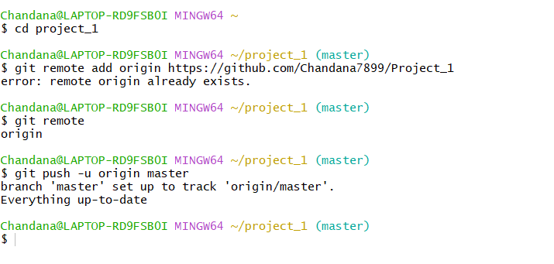

1. **Induce Conflicts, Open and Close Pull Requests** 
   1. **Git Merging & Conflicts:**

* git merge: Integrate changes from one branch into another.

* Conflicts arise during merging when Git cannot automatically reconcile diverging changes.

* Use a merge tool to resolve conflicts.

* git mergetool: Command to launch the configured merge tool.

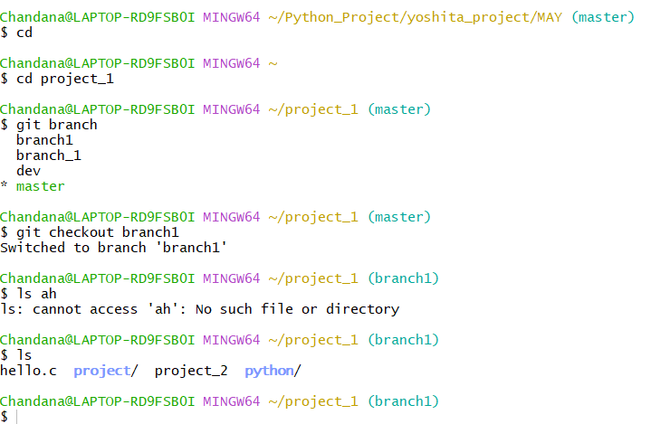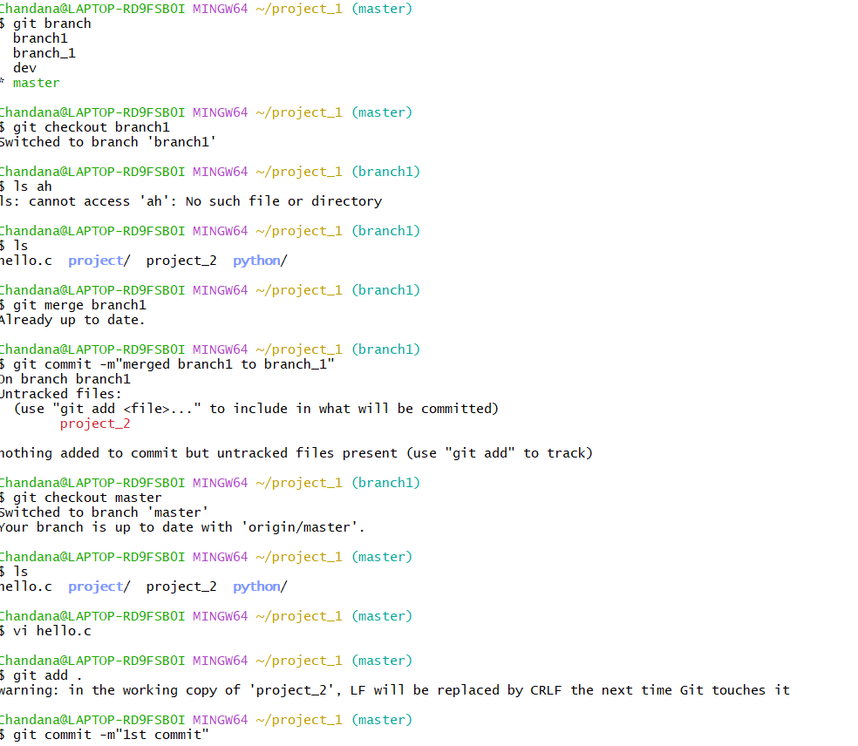

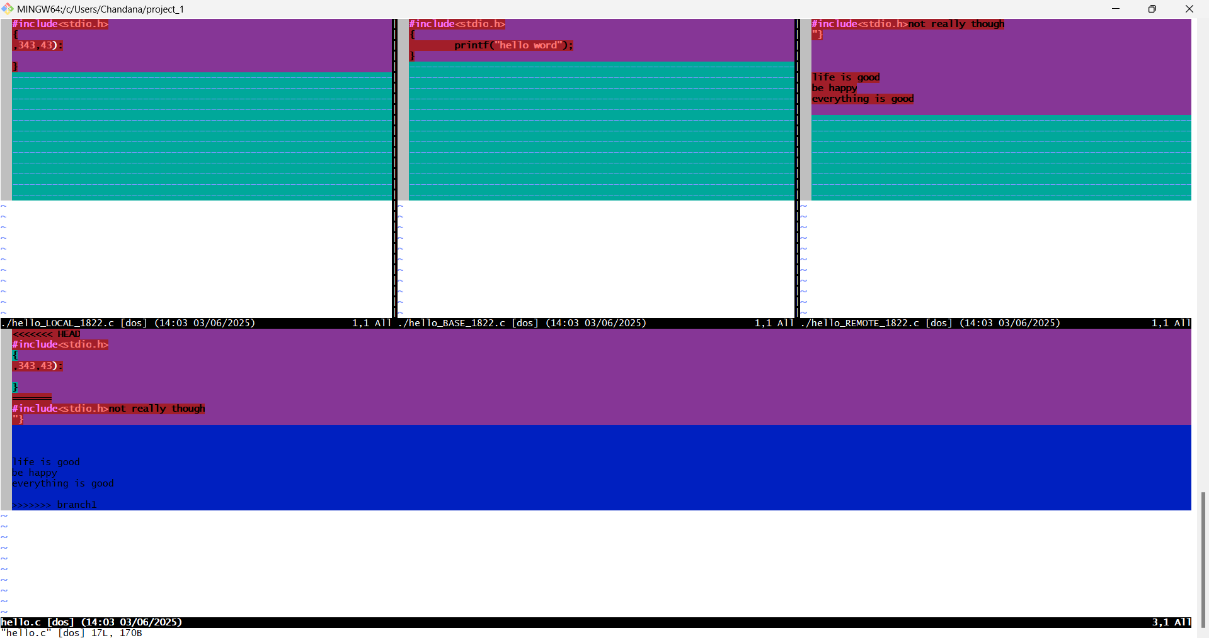

**2. Gitignore**: *. gitignore file: Specifies intentionally untracked files that Git should ignore.

* Files listed in .gitignore will not be tracked by Git and will not be mirrored on GitHub.

**3. Pull Requests**: * Opening a pull request

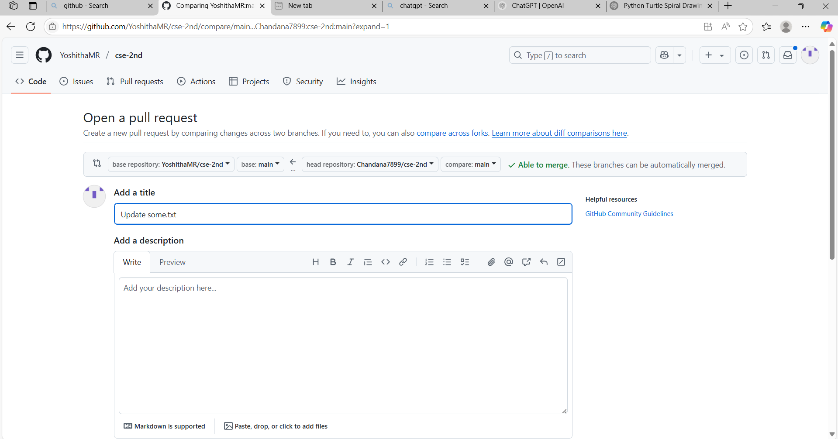

2. * Closing a pull request

